First Mardi Gras Inc  MEMBERSHIP FORM |  |  |  |  |  |  |  |  |  |  |  |  |  | 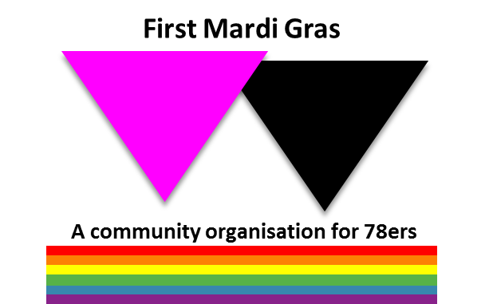
I wish to Join/Renew my membership of First Mardi Gras Inc.
I confirm that I am a 78er who participated in the first Mardi Gras on 24 June 1978 and/or in related protests from July to August 1978.
I agree to support the objectives of First Mardi Gras Inc. – see 78ers.org.au.
Name:
Address:
Phone:
Email:
Signature: |  |  |  |  |  |  |  |  |  |  |  |  |  |  |  | Date:
 | $10 one year’s Membership |  |  |  |  |  |  |  |  |  |  |  | $17 two year’s Membership
 | $25 three year’s Membership |  |  |  |  |  |  |  |  |  |  |  | $5 a year Concession Membership
 | Donation:  (optional) |  |  |  | $ |  |  |  |  |  |  |  | All donations gratefully received and duly acknowledged.
Direct Deposit:  ANZ Bank, Broadway |  |  |  |  |  | Name:  First Mardi Gras Inc. |  |  |  | BSB: 012030 |  |  |  |  |  |  |  | Account: 305190634
 |  |  |  |  |  | Please use your name as the reference for direct deposits and email this form to membership@78ers.org.au or post to our PO Box below.
Cheques: PO Box 1029 Glebe NSW 2037
Approved: |  |  |  |  |  |  |  |  |  |  |  |  |  |  |  |  | Date:
Received: |  |  |  | Deposit  Receipt No: |  |  |  |  |  |  |  | Cheque  Number: |  |  |  |  |  |  |  | Cash

